Book of requirements

Julius Valentin Burlet

Contents

Functional Requirements 2

Quality Requirements 2

Boundary conditions 2

Introduction 3

Goals 3

UI / Mock-up 3

Colours 3

Schedule 4

# Functional Requirements

|  |  |
| --- | --- |
| Num | Requirement |
| F1 | The Website has a header, footer, navigation area, info area, and a main display area. |
| F2 | A Welcome page exists. |
| F3 | There are at least 4 other pages beside the Welcome page |
| F4 | There is a menu where you can visit all pages |
| F5 | There is a picture on every page to support the text. |
| F6 | On every page has to be the name of the creator of the page. |
| F7 | On every page is a text with at least 8 full sentences as descript |

# Quality Requirements

|  |  |
| --- | --- |
| Num | Requirement |
| Q1 | The design has to adapt if you are on a phone or pc. |
| Q2 | The website has to be tested with W3C. |
| Q3 | Optimised for Windows 10 on a desktop and phone. |

# Boundary conditions

|  |  |
| --- | --- |
| Num | Condition |
| R1 | Documentation is in a word file. |
| R2 | Using HTML5 and CSS3 |
| R3 | Delivery according to teacher's instructions: Project fully functional and can be opened directly in Visual Studio Code, further documents according to administrative instructions. |
| R4 | The website only needs to be tested on two browsers (must be named in the documentation). |
| R5 | This may be followed by further requirements according to your specifications. |

# Introduction

On the website you can read the résumé of Julius Valentin Burlet.

# Goals

The goal is to have a website where you can read the résumé of Julius V. Burlet. It has a nav area where you can switch between different categories which have a description of me and what I do exactly. Every page has pictures to support the category. It also contains some projects.

# UI / Mock-up

Colours

|  |  |  |
| --- | --- | --- |
| Colour | RGB | HEX |
| Purple | 82, 0, 163 | #5200A3 |
| Yellow | 240, 197, 24 | #F0C518 |
| Grey | 221, 221, 221 | #DDD |

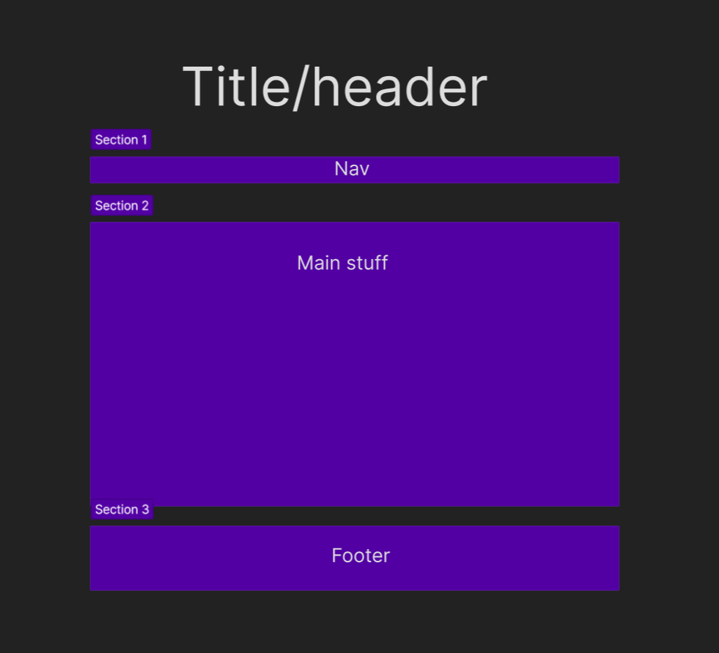

This site is very possible to do in the given time due to its simplicity and structure. The colour “yellow” was not used in the mock-up, because it will be used for details like small lines ecetera.

# Schedule

|  |  |
| --- | --- |
| 15.06.2023 | Main page HTML finished |
| 15.06.2023 | Other pages HTML finished |
| 22.06.2023 | CSS Finished for all pages |
| 29.06.2023 | Optimisation for mobile and two browsers |